Recognized pattern: Aples_variety1

The form of the pattern:

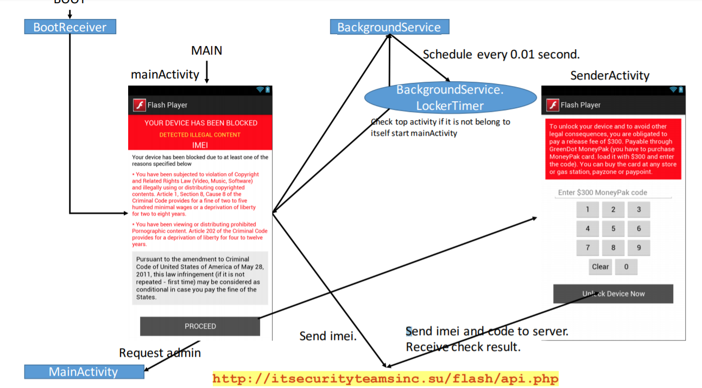

The name of the corresponding sample app:

Flash Player

The name of the identified app:

OGS

For functional modules:

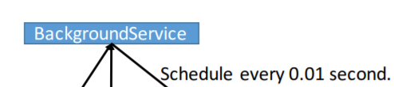

Corresponding to the key code in sample app：

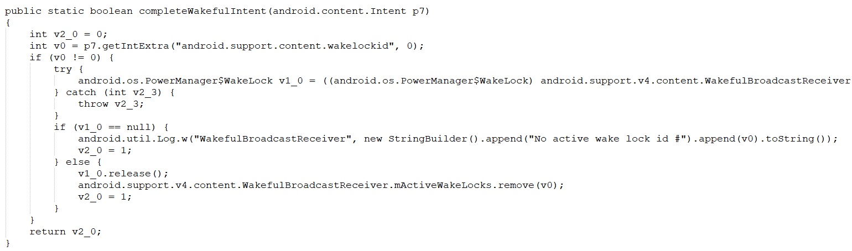

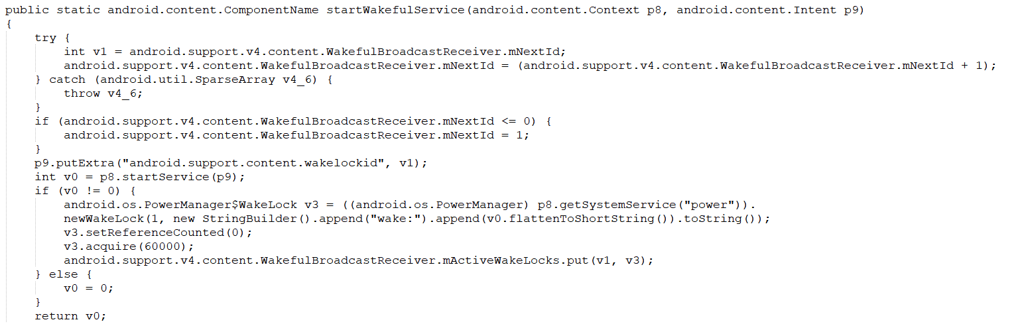

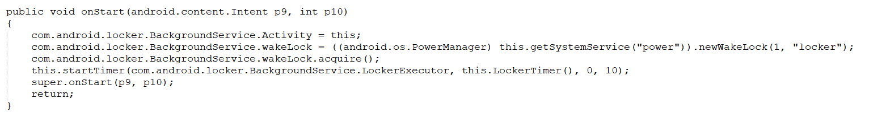

Corresponding to the key code in this app:

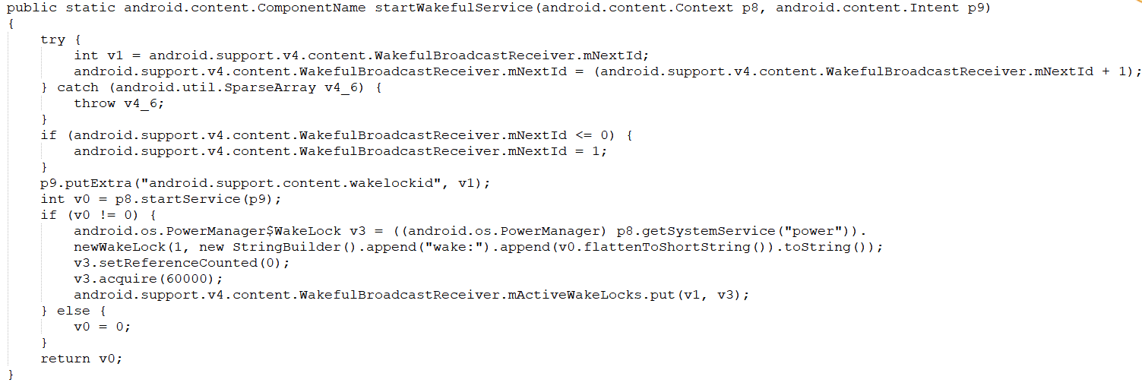

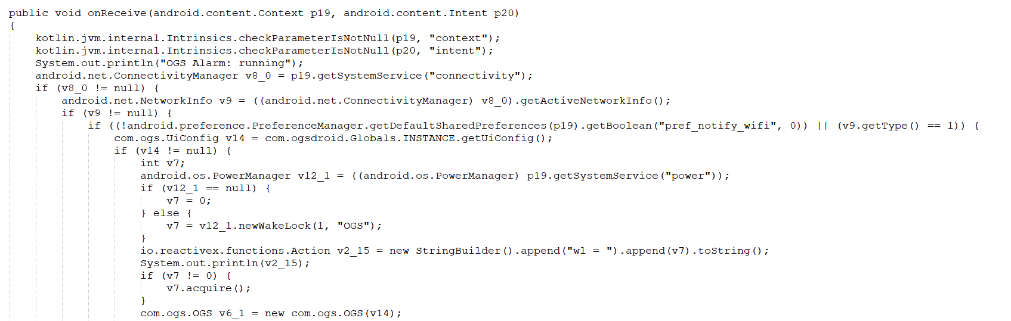

For functional modules (access to personal information such as telephone information):

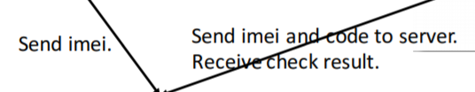

Corresponding to the key code in sample app:

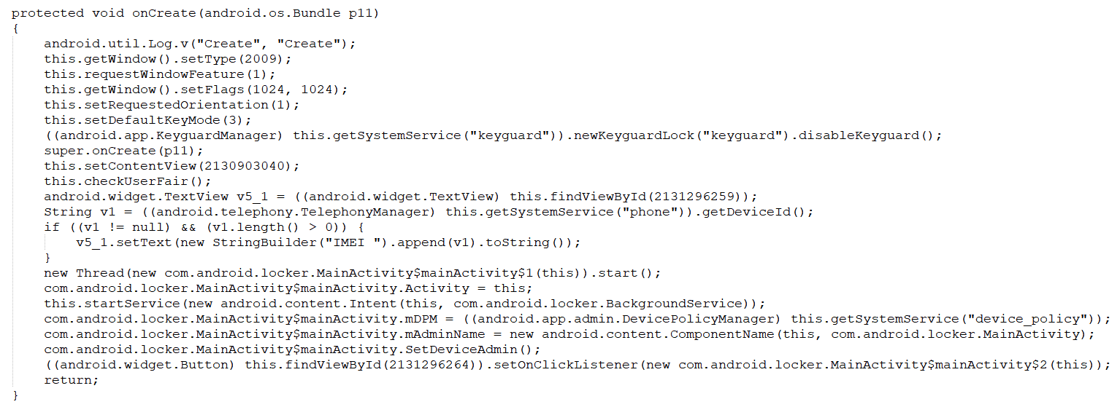

Corresponding to the key code in this app:

